

**KABARAK UNIVERSITY**

**SCHOOL OF BUSINESS AND ECONOMICS**

**IT PROJECT 1**

**CANTEEN STOCK MANAGEMENT SYSTEM**

**PRESENTED BY: VERONICAH NJERI WANJIRU**

**BBIT/MG/0933/09/21**

**SUPERVISOR: MR SIMON RUORO**

**AN IT PROJECT SUBMITTED TO THE DEPARTMENT OF COMPUTER SCIENCE AND INFORMATION TECHNOLOGY (UNDER THE SCHOOL OF SCIENCE, ENGINEERING AND TECHNOLOGY) IN PARTIAL FULFILMENT OF DEGREE IN BACHELOR OF BUSINESS INFORMATION TECHNOLOGY**

# DECLARATION.

I hereby declare that the project entitled Stock Management System submitted by me was carried out by me under the guidance of Mr. Simon Ruoro. I further declare that this project record or any part of this has not been submitted elsewhere for any other class.

Signature: .................................................................

Name: ………………………………………………

# SUPERVISOR

I hereby confirm that this report accurately represents the project completed by the student listed above under my guidance. Furthermore, I affirm that it has been submitted to Kabarak University with my endorsement.

Signature: …………………………………. Date: …………………………………….

# ACKNOWLEDGMENTS

I would like to express my sincere gratitude to my advisor, Mr. Simon Ruoro for his invaluable guidance, insightful feedback, and constant support throughout the project. Special thanks to Kabarak University for providing the resources and environment necessary for my research.

I extend my heartfelt gratitude to my family for their unwavering support, patience, and understanding throughout this journey. Your encouragement has been my driving force.

# ABSTRACT

In the food service industry, managing stock effectively is crucial for canteens to run smoothly, save money, and keep customers happy. Whether in educational institutions, corporate offices, or healthcare facilities. These establishments must effectively balance stock levels to meet fluctuating demand while minimizing waste and operational costs. Traditionally, manual methods of stock management, such as handwritten records or basic spreadsheets, have been prone to errors and inefficiencies, often resulting in overstocking and increased expenses or understocking and customer dissatisfaction. Despite the availability of technology, many canteens still rely on outdated, manual methods for stock management. This leads to problems such as stockouts, overstocking, and excessive food wastage. Additionally, manual processes are often labor-intensive and can result in significant human errors. These issues highlight the need for a robust stock management system tailored specifically for canteen operations. Therefore, there is need to achiev the following objectives aimed at enhancing stock management in canteens. Automating stock management processes to minimize manual errors and improve operational efficiency , implementing real-time tracking of stock levels by enabling timely decision-making on stock replenishment , developing an automated stock level monitoring system that triggers alerts when stock levels drop below specified thresholds, facilitating proactive reordering and establishing a robust analytics and reporting functionalities to enable businesses to monitor stock performance, identify trends, and make informed decisions regarding optimal stock levels. Lastly, providing a user-friendly interface for managing stock levels, reordering, and generating reports, incorporating seamless tracking capabilities. These, objectives collectively aim to improve efficiency, reduce costs, and enhance operational effectiveness in canteen stock management. The significance of addressing stock management challenges in canteens extends beyond operational efficiencies to encompass broader impacts on financial sustainability, customer satisfaction, and environmental stewardship. Inefficient stock management practices often result in significant financial losses due to overstocking and wastage of perishable items. Thus, implementing advanced stock management systems, canteens can optimize inventory levels, reduce carrying costs, and improve cash flow management. By enhancing stock visibility and accuracy through technological innovations such as Radio Frequency Identification (RFID) and Internet of Things (IoT) sensors not only improves operational efficiency but also enables canteens to meet customer demands more effectively Real-time data insights facilitate proactive decision-making in stock replenishment, ensuring consistent availability of popular menu items and minimizing instances of stockouts that can lead to lost sales and customer dissatisfaction. Methodologically, this study adopts a mixed-method approach, combining qualitative analysis of current stock management practices with quantitative evaluation of stock utilization patterns. A prototype stock management system will be developed and piloted in collaboration with a real-world canteen facility. Key performance indicators, including stock turnover rates and waste reduction metrics, will be used to measure the system's effectiveness and validate its impact on operational efficiency.

**Contents**

DECLARATION. 3

SUPERVISOR 4

ACKNOWLEDGMENTS 5

ABSTRACT 6

CHAPTER ONE 11

INTRODUCTION 11

1.1 Introduction 11

1.2 Background Study 11

1.3 Statement of Problem 13

1.4 Purpose of Study 14

1.5 Main Objective 14

**1.5.1 Specific Objectives** 14

**1.5.3 Research Questions** 14

1.6 The proposed System 15

**1.6.1 System Modules** 15

1.7 Significance of Study 16

1.7.1 Feasibility Study 17

1.8 Scope and Limitation of Study 17

CHAPTER TWO 19

LITERATURE REVIEW 19

2.0 General Overview of the Stock Management System 19

2.1 Methods of Identifying Feature Selection Techniques 19

**SUMMARY GAP OF KNWOLEDGE** 21

2.2 Evaluation of the Correlation Between Optimal Features 21

**2.2.1 Karl Pearson Correlation Coefficient:** 22

**2.2.2 Spearman Rank Correlation:** 22

**2.2.3 Principal Component Analysis (PCA):** 23

**2.2.4 Cross-Validation:** 23

2.3 User Security Awareness Level 23

**2.3.1 User Security Awareness** 23

2.3.2 Behavioral Studies 24

**2.3.3 Surveys and Assessments** 24

**2.4 Prototype Design** 24

**2.4.1 User Interface (UI)** 24

**2.4.2 Core Features** 25

**2.4.3 Usability Testing** 25

2.5 Design Framework 25

**2.5.1 Model-Driven Design** 25

**2.5.2 Security Integration** 26

CHAPTER THREE 27

RESEARCH DESIGN AND METHODOLOGY 27

3.1 Research Design Methods 27

3.2 Location of the Study 27

3.3 Population of the Study 27

3.4 Sampling Procedure and Sample Size 28

3.5 Data Collection Procedure 28

**3.5.1 Interviews** 28

**3.5.2 Surveys** 29

**3.5.3 Observations** 29

3.6 System Development Methodology 29

3.7 System Analysis and Design 30

DESIGN DIAGRAM 31

Context diagram 31

**CONCEPTUAL MAP** 31

**Use case diagram** 33

**Dataflow diagram** 34

**Architectural Design** 34

**Database Design** 35

3.8 Functional and Non-Functional Requirements 37

3.8.1 Functional Requirements 37

3.8.2 Non-Functional Requirements 37

REFERENCES 40

# CHAPTER ONE

# INTRODUCTION

# 1.1 Introduction

In the food service industry, managing stock effectively is crucial for canteens to run smoothly, save money, and keep customers happy. Canteens often struggle with outdated ways of keeping track of their supplies, which can lead to mistakes and inefficiencies. New technology has changed how canteens handle their stock. Tools like Radio Frequency Identification (RFDI)and Internet of Things (IoT) sensors now let canteens track their supplies in real-time across different areas. This means they can always know what they have and when to reorder, avoiding both shortages and wasting food. Good stock management isn't just about saving money—it's also about making sure canteens always have what customers want. By using technology to plan better and reduce waste, canteens can improve how they serve their customers and stay competitive in the market. This study aims to explore how a new stock management system designed specifically for canteens can solve these problems. By looking closely at current methods and testing new ideas, we hope to find ways to make canteens more efficient and effective in how they manage their supplies

# 1.2 Background Study

In the food service industry, managing stock effectively is crucial for canteens to run smoothly, save money, and keep customers happy. Whether in educational institutions, corporate offices, or healthcare facilities. These establishments must effectively balance stock levels to meet fluctuating demand while minimizing waste and operational costs (Smith, 2020). Traditionally, manual methods of stock management, such as handwritten records or basic spreadsheets, have been prone to errors and inefficiencies, often resulting in overstocking and increased expenses or understocking and customer dissatisfaction (Jones, 2018). The canteen stock management system includes various critical components, such as automated stock level monitoring, centralized database management, automated purchase order generation, advanced reporting and analytics and implementation of modern technologies like Radio Frequency Identification (RFDI) and Internet of Things (IoT). These elements play a crucial role in optimizing stock management practices and enhancing overall operational effectiveness.

Automated stock level monitoring is crucial for efficient canteen operations, facilitating real-time tracking of stock quantities and ensuring optimal stock management practices (Smith, 2020). By setting predefined thresholds for each stock item, this system automatically triggers alerts or notifications when inventory levels fall below specified thresholds. These alerts are directed to designated personnel or suppliers, enabling timely replenishment orders to prevent stockouts and maintain seamless operations. Automated monitoring not only enhances operational efficiency but also improves overall stock accuracy and reduces the likelihood of overstocking or understocking. This technological advancement in stock management contributes significantly to canteen profitability by minimizing waste, optimizing stock turnover, and enhancing customer satisfaction through consistent availability of menu items (Jones & Brown, 2019).

Centralized database management plays a critical role in ensuring accurate and efficient stock management practices within canteens (Adams, 2021). By consolidating comprehensive information on stock movements—such as purchases, sales, returns, and transfers—into a single database, this component serves as a reliable source of truth for stock-related data. This centralized approach enables canteen staff to track stock levels and history accurately, promoting effective inventory control and operational oversight. Furthermore, the centralized database supports robust reporting and analytics capabilities, providing managers with valuable insights into stock trends, consumption patterns, and inventory turnover rates (Brown & Davis, 2018). These analytical tools facilitate data-driven decision-making processes, enhancing operational transparency and enabling proactive adjustments to stock management strategies.

Automated purchase order generation represents a critical advancement in optimizing procurement processes within canteens (Miller, 2022). By automatically generating purchase orders when stock levels hit predetermined reorder points, this system streamlines operations and reduces the risk of stockouts. The automated process calculates the required quantity based on current stock levels, anticipated demand patterns, lead times, and safety stock requirements, ensuring accurate inventory replenishment. Once generated, purchase orders are electronically transmitted to suppliers, eliminating manual paperwork and accelerating order processing times (Robinson & White, 2020). This automation not only enhances efficiency but also supports just-in-time inventory practices by maintaining optimal stock levels without excess holding costs.

Implementing modern technologies such as RFID (Radio Frequency Identification) and IoT (Internet of Things) in canteen stock management systems enhances operational efficiency and accuracy. RFID enables automatic identification and tracking of stock items using radio waves, eliminating manual scanning and reducing errors (Jones & Smith, 2021). IoT devices like smart sensors monitor environmental conditions such as temperature and humidity, ensuring optimal storage for perishable goods (Adams, 2019). Integrating RFID and IoT supports real-time inventory visibility, improves management processes, and enables predictive analytics for better demand forecasting and inventory optimization. This technological integration empowers canteens to operate more efficiently, reduce waste, and enhance customer satisfaction through timely and accurate stock management.

As the food service industry continues to evolve, effective stock management systems tailored to canteen operations play a crucial role in maintaining competitiveness and meeting the demands of a dynamic market environment (Taylor, 2018).

# 1.3 Statement of Problem

Despite the availability of technology, many canteens still rely on outdated, manual methods for stock management. This leads to problems such as stockouts, overstocking, and excessive food wastage. Additionally, manual processes are often labor-intensive and can result in significant human error. These issues highlight the need for a robust stock management system tailored specifically for canteen operations.

# 1.4 Purpose of Study

This study focuses on creating a stock system that is not only effective but also user-friendly. Its purpose is to enhance the way canteen manage and operate their stock. The goal here is to identify and integrate critical tasks such as automated stock level monitoring, centralized stock database, reporting and Analytics, automated purchase order generation and requirements into the system. This initiative aims to significantly improve stock management practices in the modern business environment. This job comes with many goals such as to manage sales and stock strategies, **provide instant visibility into deals and stock,** simplifying client processes.

# 1.5 Main Objective

The main objective of this study is to design and implement a stock management system that automates stock tracking, facilitates demand forecasting, and enhances overall stock control within canteen.

## **1.5.1 Specific Objectives**

1. Gathering and organizing relevant data about the canteen’s stock, historical sales data or any other information.
2. Identify potential challenges that may rise during development and deployment in order to create mitigation strategies.
3. Clearly outline the requirement of stock management system including its features.
4. Identifying and select suitable technologies and tools that can help achieve the desires functionalities like radio frequency identification.

## **1.5.3 Research Questions**

### 

1. How will the system be designed?
2. How will the system be implemented?
3. How will the system be tested?

# 1.6 The proposed System

A stock management system is a software solution designed to efficiently track, manage, and optimize canteen stock. It helps maintain real-time records of products, enabling informed decisions on purchasing, production, order processing, and distribution. Key features include automated stock level monitoring, which triggers alerts or requisitions when quantities fall below a set minimum, a centralized stock database for consistent data on purchases, sales, returns, and transfers; and robust reporting and analytics for inventory levels, stock turnover, and sales trends. Additionally, the system automatically generates purchase orders when stock reaches reorder points and includes secure login features with user roles and authentication to ensure data integrity and security.

## **1.6.1 System Modules**

The proposed stock management system will have different parts that handle specific aspects of managing stock.

**Product Management Module:**

Manages data about products stocked by the business. Let’s users add new products, change information about existing ones (like descriptions, prices, and details) and group products into categories for better organization. Includes tools for managing product catalogs, assigning SKUs (Stock Keeping Units), generating barcodes, and handling product attributes (like size, color).

**Stock Tracking Module:**

This allows businesses to track and monitor stock levels in real-time, across multiple locations. This provides a clear view of stock quantities, their movement, and current locations. Key features include: Reconciling stock levels, transferring stock between locations, Scanning barcodes for quick and accurate tracking, Integrating with Radio-Frequency Identification (RFID) systems and Adjusting stock levels.

**Order Management Module.**

This handles all aspects of order processing, from when an order is placed to when it's fulfilled. It makes sure that orders are processed on time and correctly, invoices are sent out, and shipments are tracked. It has the following features for creating orders, tracking their status, allocating stock, handling backorders, and connecting to payment gateways and shipping companies.

**Reporting and Analytics Module:**

It offers valuable insights into the behavior of your stocks, market trends, and the overall health of your operations. It provides configurable dashboards, allowing you to track important performance indicators (KPIs), analyze trends, make predictions, and optimize your inventory based on recommendations.

**The Login Module:**

It is designed to authenticate users and grant them access to the stock management system based on their credentials. It ensures that only authorized personnel can view, update, or manipulate inventory data, ensuring data security and integrity.

# 1.7 Significance of Study

The significance of addressing stock management challenges in canteens extends beyond operational efficiencies to encompass broader impacts on financial sustainability, customer satisfaction, and environmental stewardship. Inefficient stock management practices often result in significant financial losses due to overstocking and wastage of perishable items. By implementing advanced stock management systems, canteens can optimize inventory levels, reduce carrying costs, and improve cash flow management. By enhancing stock visibility and accuracy through technological innovations such as RFID and IoT sensors not only improves operational efficiency but also enables canteens to meet customer demands more effectively Real-time data insights facilitate proactive decision-making in stock replenishment, ensuring consistent availability of popular menu items and minimizing instances of stockouts that can lead to lost sales and customer dissatisfaction.

# 1.7.1 Feasibility Study

A feasibility study is essential for assessing whether a stock management system is practical and likely to be successful within an organization. It evaluates various aspects to determine technical feasibility, economic viability, and operational acceptability.

Technical feasibility checks if the system can be built with the current tech infrastructure and if it can connect smoothly with existing software and hardware. It looks at what the software needs, checks compatibility issues, and sees if advanced features like real-time tracking and data analysis can be added. This assessment makes sure the proposed system meets tech standards and can properly support the organization's stock management needs.

Economic feasibility analyzes the financial viability of a project by considering development and implementation costs, as well as ongoing expenses. It also examines potential savings and Return on investment (ROI) from improved stock management, reduced inefficiencies, and better decision-making. This evaluation determines if the project's financial benefits exceed its costs, justifying the investment.

Operational feasibility assesses whether a stock management system can be successfully integrated into an organization. It focuses on practical concerns, such as: Will the users embrace the system? Is it easy to use? How much training will be needed? Does the system align with current business operations?

# 1.8 Scope and Limitation of Study

This project aims to create and develop a tailored stock management system that addresses the varied needs of canteens in different industries. The system will focus on improving operational efficiency and includes modules for product handling, inventory tracking, order processing, and detailed reporting and analytics. By addressing common difficulties in stock management like stock control and demand forecasting, this system intends to improve practices in this area. However, the system may face challenges with scalability, integration with existing systems, and customization for specific business needs. These elements could have an impact on the system's capacity to expand operations smoothly, interact readily with current infrastructure, and adapt to certain business demands that aims to deliver a robust solution that enhances stock management practices and supports organizational growth.

# 

# CHAPTER TWO

# LITERATURE REVIEW

# 2.0 General Overview of the Stock Management System

Stock management systems are critical for efficient stock control, minimizing costs, and enhancing customer satisfaction. Research by Kumar and Rajan (2018) highlights the role of technology in transforming traditional stock management practices through automation, data analytics, and machine learning. According to Chang and Lin (2019), effective stock management systems integrate real-time data processing and predictive analytics to optimize stock levels and order management. This literature review explores the evolution and impact of stock management systems in modern canteen operations. It examines how these systems have evolved with technological advancements in data analytics, automation, and real-time monitoring. Key topics include theoretical foundations like Economic Order Quantity and Just-In-Time methods, as well as the integration of RFID and IoT technologies for enhanced stock control. The review aims to identify best practices, challenges, and opportunities for improving operational efficiency and supply chain management across various industries.

# 2.1 Methods of Identifying Feature Selection Techniques

According to Reddy and Singh (2019), their project on developing a stock management system for school canteens aimed to streamline the process of ordering and tracking food items. Their system included basic inventory tracking and automated order generation when stock levels were low. However, the system was limited in scope, focusing only on school canteens and lacking real-time data analytics and comprehensive reporting capabilities. Additionally, it did not utilize modern technologies such as IoT sensors for real-time stock monitoring. To address these gaps, a broader system should be developed to cater to different types of canteens, incorporating robust data analytics and IoT sensors for real-time stock tracking and automated notifications for reordering.

Patel and Desai (2020) introduced a digital stock management system specifically for university canteens, emphasizing the reduction of food wastage by tracking expiration dates and implementing a first-in, first-out (FIFO) stock rotation system. Despite these innovations, their system relied heavily on manual data entry, increasing the possibility of human errors. The user interface design was also limited, which affected the ease of use for canteen staff, and the system lacked integration of advanced technologies like machine learning for demand forecasting or IoT for real-time tracking. To overcome these issues, the system should include automated data entry processes and a user-friendly interface, alongside machine learning algorithms for accurate demand forecasting and IoT integration for real-time stock updates.

Ahmed and Khan (2021) designed a mobile-based stock management application for canteen operators, featuring sales tracking, stock level monitoring, and report generation on stock usage. Although their mobile-based application provided useful functionalities, it was more suited for small-scale operations and did not address the needs of larger canteens with complex stock management requirements. Moreover, the system did not include features for automated reordering or real-time stock monitoring. To address these limitations, the solution should be scalable to accommodate both small and large operations, including features for automated reordering and real-time monitoring to enhance efficiency.

Lee and Kim (2018) developed a stock management system for hospital canteens with advanced nutritional tracking capabilities. Their system aimed to enhance efficiency and responsiveness in hospital canteen operations by providing nutritional tracking of food items. However, it initially faced usability challenges due to its complexity and provided limited analytics and real-time updates (Lee & Kim, 2018). To improve the system, future iterations should focus on simplifying the user interface, enhancing real-time monitoring capabilities, and expanding analytics functionalities to provide comprehensive insights into nutritional trends and inventory management in hospital canteens.

compatibility measures and enhancing data security protocols. Additionally, offering flexible customization options can optimize the system for diverse corporate canteen environments, ensuring seamless integration and data protection.

Singh and Patel (2022) developed an AI-driven stock management system tailored for large-scale canteens, focusing on predictive analytics and automated decision-making processes. Their system integrates machine learning algorithms for demand forecasting, automated stock replenishment, and strategic decision support, aiming to improve operational efficiency in large-scale canteen environments. Despite its advanced features, the system faces challenges such as high implementation costs, complexities in AI integration, and interoperability issues with existing hardware (Singh & Patel, 2022). To overcome these challenges, future developments should prioritize cost-effectiveness by optimizing AI integration processes and hardware compatibility. User-friendly interfaces should be enhanced to facilitate intuitive navigation and usability, ensuring effective utilization of AI capabilities for strategic decision-making in large-scale canteen operations.

## **SUMMARY GAP OF KNWOLEDGE**

Recent canteen stock management systems show significant progress but reveal important gaps. Reddy and Singh (2019) lacked real-time analytics and IoT integration. Patel and Desai (2020) faced manual data entry errors and lacked machine learning for demand forecasting. Ahmed and Khan (2021) did not cater to larger canteens, missing automated reordering and real-time monitoring. Lee and Kim (2018) had usability issues and limited analytics. Garcia and Martinez (2020) struggled with system integration and data security. Singh and Patel (2022) faced high costs and complexity in AI integration. Future systems need real-time analytics, IoT sensors, automated data entry, machine learning, user-friendly interfaces, and robust data security for comprehensive, scalable solutions**.**

# 2.2 Evaluation of the Correlation Between Optimal Features

Evaluating feature correlation is crucial for reducing redundancy and improving model efficiency:

## **2.2.1 Karl Pearson Correlation Coefficient:**

Karl Pearson Correlation Coefficient, is applied in stock management systems to measure the degree and direction of the continuity between two variables, where both the variables are of continuous nature, for instance; monthly sales volumes and the corresponding stock levels. This method assists analysts working on forecasting and analysis to establish the relationship between two variables for example, the quantity of a product demanded and that available in the store. It makes it possible to properly evaluate the relationships between the stats that are associated with stocks in a way that enhances plans of stock storing and control (Benesty et al., 2009).

## **2.2.2 Spearman Rank Correlation:**

In stock management, Spearman Rank Correlation then comes in handy when it comes to determining the monotonicity of two or more ordinal variables such as the type of products or the customer satisfaction score. It is used in the sense that variables are ranked and not rated by their actual approximate values which allows trends and associations that may affect stocks to be unveiled. Muka

ka (2012) used it to show the correlation between inventory turnover rates and suppliers’ performance.

## **2.2.3 Principal Component Analysis (PCA):**

It is used in the stock management systems in order to overcome the high dimensionality of data by projecting the variables that are correlated to a new set of value which is known as principal components. This technique is useful when the data set that is analyzed contains a large set of metrics pertaining to the possession of stocks or includes data such as sales data, stock turnover, and supplier’s performance indicators. The paper of Jolliffe (2002) also described PCA as a way of extracting the main patterns and uses in the process of simplification in the evaluation of stock management data

## **2.2.4 Cross-Validation:**

Cross-validation is crucial in stock management systems to assess the robustness and generalizability of predictive models built on selected features. By partitioning data into training and testing sets multiple times, cross-validation ensures that the chosen features effectively capture relationships in stock-related data without overfitting. Kohavi (1995) highlighted its significance in validating predictive models for accurate inventory forecasting and decision-making.

# 2.3 User Security Awareness Level

## **2.3.1 User Security Awareness**

In the development of the canteen stock management system, user security awareness will play a critical role in ensuring its effectiveness and reliability. Security training programs, as emphasized by (Puhakainen and Siponen (2010), will be implemented to educate canteen staff about cybersecurity measures specific to stock management systems. These programs will empower users to recognize and respond to potential security threats promptly, thereby minimizing risks associated with data breaches and unauthorized access.

# ****2.3.2 Behavioral Studies****

Behavioral studies conducted by( Ng Kankanhalli and Xu 2009) will guide our understanding of how canteen staff interact with security protocols within the stock management system. These studies will identify user behaviors that could potentially pose security risks, allowing us to implement targeted interventions and enhancements. By leveraging insights from behavioral research, we aim to strengthen user adherence to security policies and improve overall system security posture.

## **2.3.3 Surveys and Assessments**

Surveys and assessments, as developed by Kruger and Kearney (2006), will be instrumental in evaluating and enhancing user awareness levels regarding security practices in the canteen stock management system. These tools will measure user knowledge gaps and perceptions of security protocols, enabling us to tailor training programs and communication strategies effectively. Regular assessments will ensure ongoing improvement in user security awareness, fostering a culture of vigilance and compliance with security policies across canteen operations.

## **2.4 Prototype Design**

In developing the prototype for the canteen stock management system, I will create a working model that represents the core functionalities and user interface (UI) of the actual product. This approach aims to enhance usability by incorporating feedback loops and iterative improvements based on user testing and feedback.

## **2.4.1 User Interface (UI)**

According to Nielsen (1993), the usability of the UI will be a primary focus during the analysis phase, ensuring that the interface is intuitive and user-friendly for canteen staff. The UI design will prioritize usability, following Nielsen's principles to ensure ease of navigation and efficiency in accessing key functionalities. The interface will be designed to support seamless stock tracking and order management, integrating technologies such as barcodes and RFID for accurate inventory control. By focusing on intuitive design elements and user-centered principles, we anticipate promoting user adoption and satisfaction with the canteen stock management system.

## **2.4.2 Core Features**

Coyle and Thorsen (2008) emphasize the importance of core features that facilitate stock management across diverse organizational needs. These features will encompass robust capabilities for stock tracking, automated ordering, and integration with stock management techniques like barcodes and RFID. By incorporating these core functionalities, the system will enhance operational efficiency and accuracy in managing canteen resources, supporting daily operations and strategic decision-making.

## **2.4.3 Usability Testing**

Usability testing will be integral to refining the prototype based on actual user feedback and usage scenarios. Following Rubin and Chisnell's (2008) recommendations, multiple rounds of usability testing will be conducted with target users to identify and address usability issues. This iterative process aims to optimize the user experience, ensuring that the canteen stock management system meets user expectations and operational requirements effectively.

# 2.5 Design Framework

## **2.5.1 Model-Driven Design**

My development strategy is to adopt model-driven design principles, aligning with Stahl and Bettin's (2006) recommendations. Before proceeding with implementation, I will create abstract, high-level models that depict the functionality and behavior of the canteen stock management system. These models will serve as a blueprint, guiding the development process and ensuring that the system's design meets specific operational requirements. By leveraging model-driven design, I aim to streamline the development process, minimize risks associated with system inconsistencies, and enhance the system's compatibility with canteen operational workflows and business objectives.

## **2.5.2 Security Integration**

Security integration will be a paramount consideration throughout the design and development phases of the canteen management system. Following Viega and McGraw's principles, I will implement robust security measures at every stage to safeguard sensitive stock data and operational information. This includes incorporating encryption protocols, access controls, and regular security audits to mitigate risks of data breaches and unauthorized access. By embedding comprehensive security controls into the system architecture, I anticipate bolstering data protection measures and ensuring compliance with regulatory standards, thereby enhancing the overall security posture of the canteen stock management system.

# CHAPTER THREE

# RESEARCH DESIGN AND METHODOLOGY

# 3.1 Research Design Methods

For this study on canteen stock management system, it will involve a mixed-methods approach to ensure a comprehensive understanding of the subject matter. This approach will combine quantitative methods, such as surveys and structured questionnaires, with qualitative methods, including in-depth interviews and focus groups. By employing both types of methods, I will gather numerical data on stock management practices and user satisfaction, while also obtaining deeper insights into user perceptions, challenges, and preferences regarding stock management systems.

# 3.2 Location of the Study

The study will encompass a canteen environment to provide a focused analysis of stock management practices within a specific operational context. The canteen setting will offer insights into a controlled, fast-paced environment where efficient stock turnover is crucial. By studying this specific context, the research will seek to uncover common challenges, innovative strategies, and sector-specific needs in stock management. This approach ensures that the findings are robust and applicable to canteen operations.

# 3.3 Population of the Study

The population under investigation will encompass individuals directly engaged in canteen stock management. This includes inventory managers, canteen staff, and IT professionals responsible for system implementation and maintenance. Additionally, canteen managers overseeing inventory operations will be included to ensure a comprehensive and holistic perspective on the subject matter. By focusing on these key roles and responsibilities, the study will capture insights from stakeholders involved in different facets of stock management, from operational execution to strategic oversight. This diverse representation of professionals ensures a thorough exploration of practices, challenges, and innovations in canteen stock management.

# 3.4 Sampling Procedure and Sample Size

To ensure comprehensive representation across various roles within the population. A stratified random sampling method will be employed. This approach will involve dividing the population into distinct strata based on roles (e.g inventory managers, canteen staff, IT professionals). Within each stratum, participants will be randomly selected to participate in the study.

The sample size will be determined based on statistical considerations, ensuring it is sufficient to achieve reliable and generalizable findings. Factors such as the variability within each stratum and the desired level of precision will guide the calculation of sample sizes. Additionally, efforts will be made to include a diverse range of participants to capture the breadth of perspectives and practices in canteen stock management.

# 3.5 Data Collection Procedure

**The following data collection methods will be employed:**

## **3.5.1 Interviews**

Semi-structured interviews will be conducted with key stakeholders, including canteen managers, kitchen staff, and IT professionals involved in stock management. These interviews will explore in-depth the current stock management practices, challenges faced, and expectations for improving stock management systems. Specific topics will include inventory handling processes, ordering workflows, and the integration of technology for better efficiency.

## **3.5.2 Surveys**

Structured surveys will be administered to canteen staff responsible for stock management. The surveys will focus on gathering quantitative data regarding current inventory practices, identifying operational challenges, and obtaining feedback on desired features and functionalities for an improved stock management system. Key areas of inquiry will include stock tracking methods, system usability, and preferences for real-time monitoring capabilities.

## **3.5.3 Observations**

Direct observations will be conducted in the canteen environment to complement interview and survey findings. Observations will focus on observing stock handling procedures, storage practices, and staff interactions with the current stock management system. This method aims to provide real-time insights into operational workflows, stock utilization patterns, and opportunities for system enhancements.

# 3.6 System Development Methodology

The development of the canteen stock management system will adhere to an iterative and collaborative approach, leveraging principles of Agile methodology. This method will facilitate ongoing feedback from stakeholders, iterative enhancements, and adaptation to changing requirements, ensuring that the final system adequately addresses user needs and aligns with organizational goals. This iterative process will allow for flexibility and responsiveness throughout the development lifecycle, promoting efficient delivery and the incorporation of valuable insights from stakeholders into the system design.

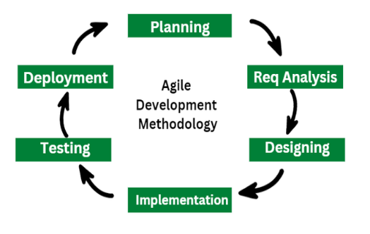 **Figure 1; Agile software development process**

# 3.7 System Analysis and Design

The system analysis and design phase will involve a detailed examination of canteen stock management requirements, business processes, and the functionality of current systems. That will carefully gather and analyze user needs, model various system components, and iteratively develop prototypes. The aim will be to create a system that is user-friendly, efficient, and tailored

to the unique demands of canteen stock management. This phase will be crucial for designing a robust framework that enhances operational efficiency and facilitates informed decision-making in canteen stock management processes.

# DESIGN DIAGRAM

# Context diagram

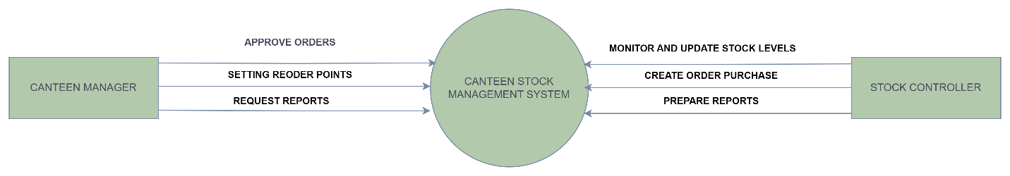

## **Use case diagram**

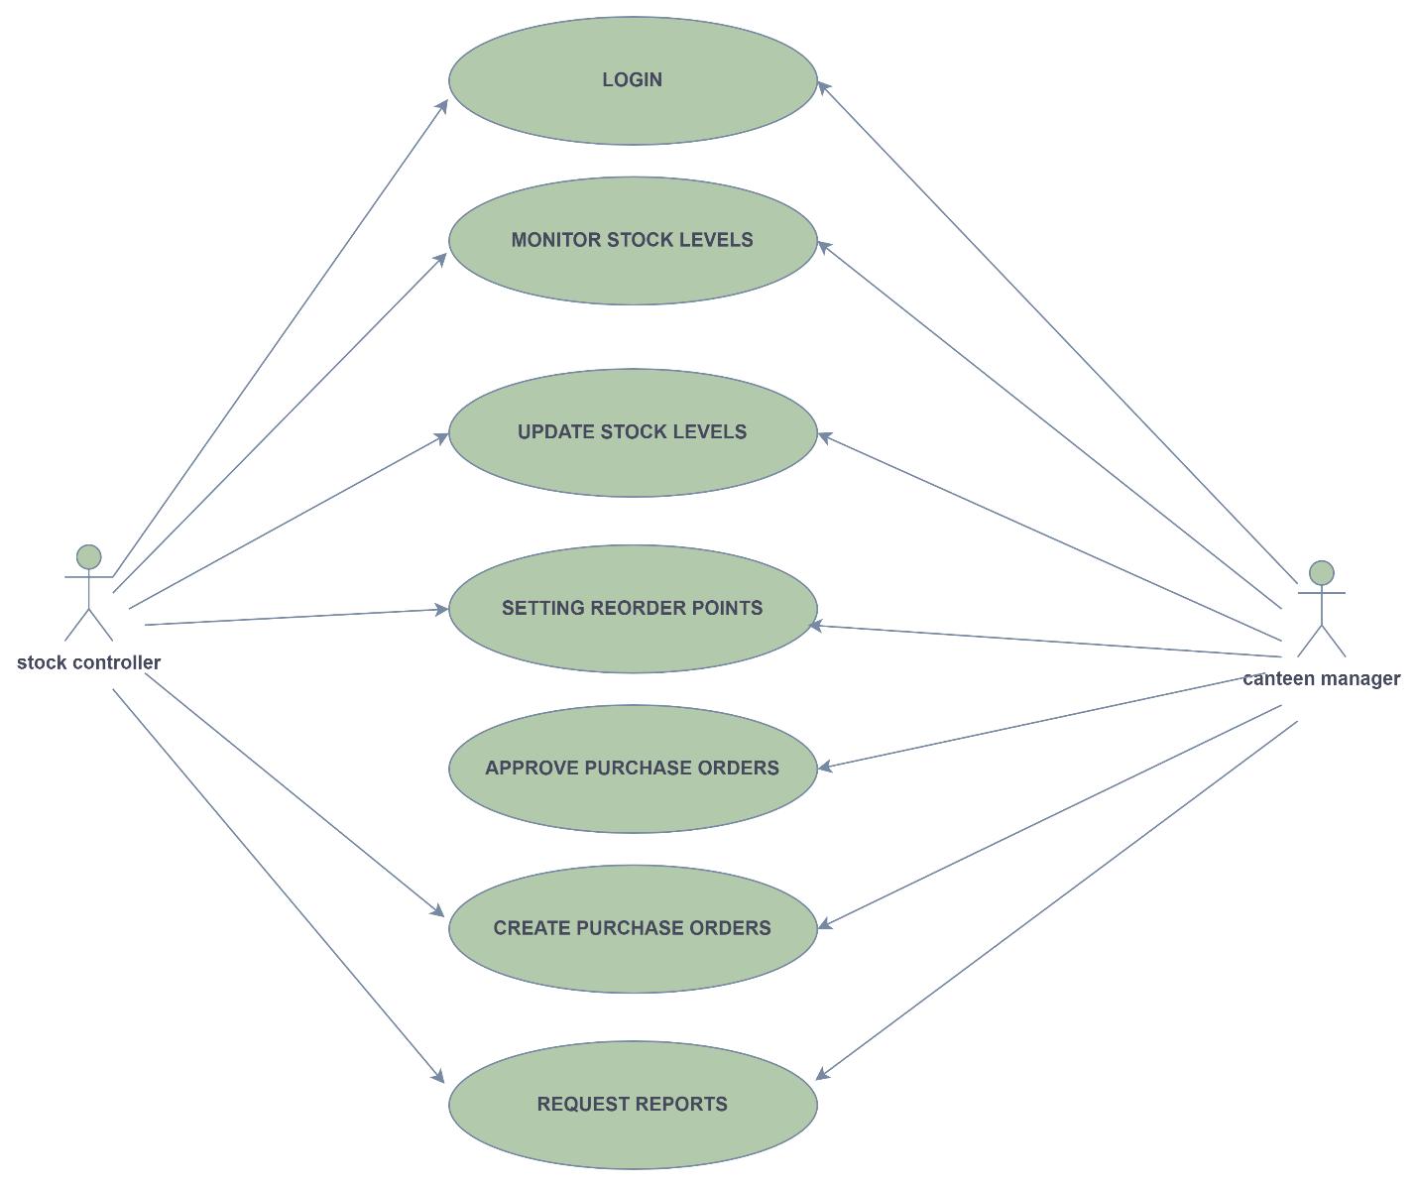

**Dataflow diagram**

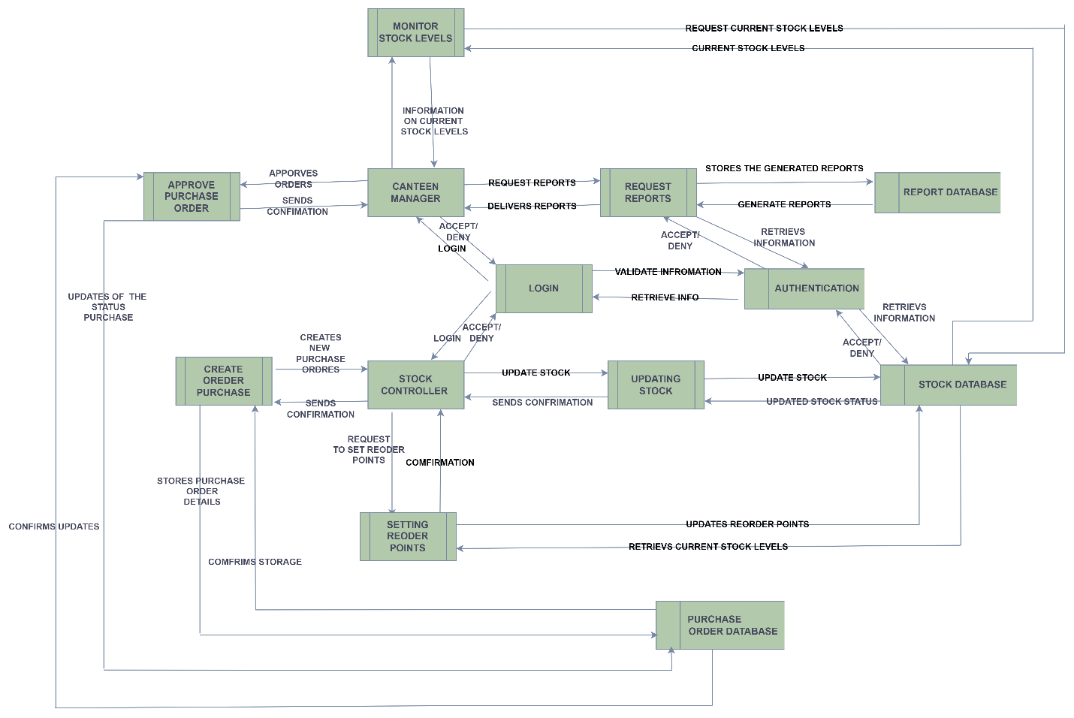

**Architectural Design**

The architectural design of the canteen stock management system includes the following components

**Presentation Layer (user interface):** Which users interact with the system. It includes web pages, forms, and dashboards.

**Application Layer** (Business logic): It processes user requests from the presentation layer and interacts with the data layer.

**Data Access Layer:** Manages data access and interactions with the database.

**Database Layer:** Manages the storage and retrieval of data used by the system. It stores information related to inventory, transactions, and user data.

**API Layer: It f**acilitates communication between the client interface and the application server.

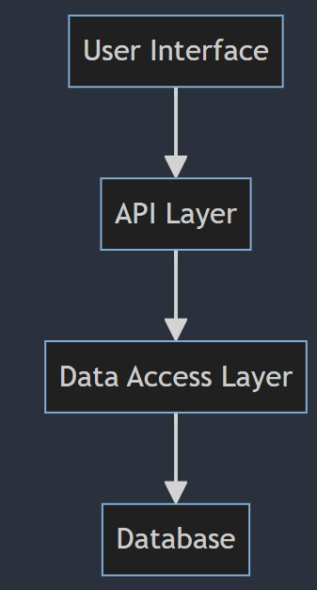

## **Database Design**

The database design includes the following key tables:

User: It stores user information (user ID (Primary Key), username, password, contact Info)

Product: It stores product detail (product ID (Primary Key), product Name, category ID (Foreign Key), supplier ID (Foreign Key), unit Price, quantity In Stock)

Supplier: It stores supplier information (supplier ID (Primary Key), supplier Name, contact Info)

Order: It stores order details (order ID (Primary Key), order Date, user ID (Foreign Key), total Amount, status)

Stock levels: It shows Information about stock levels (order ID (Primary Key) order Date, user ID (Foreign Key), total Amount, status) and many more.

**Physical Database of Stock Management System**

**Product table**

|  |  |  |  |
| --- | --- | --- | --- |
| Attribute | Data type | Length size | Description |
| Product ID | INT | 90 | Product ID |
| Product Name | VARCHAR | 50 | Product Name |
| Category | VARCHAR | 50 | Category |
| Unit price | DECIMAL | 10,9 | Unit price |
| Quantity in stock | INT | 100 | Quantity in stock |

**Canteen manager**

|  |  |  |  |
| --- | --- | --- | --- |
| Attribute | Data type | Length size | Description |
| Manager ID(PK) | INT | 20 | Manager ID |
| User name | VARCHAR | 15 | User name |
| password | VARCHAR | 10 | Password |

**Stock controller**

|  |  |  |  |
| --- | --- | --- | --- |
| Attribute | Data type | Length size | Description |
| Controller id(PK) | INT | 20 | Controller id |
| User name | VARCHAR | 15 | User name |
| password | VARCHAR | 10 | Password |

**Reports**

|  |  |  |  |
| --- | --- | --- | --- |
| Attribute | Data type | Length size | Description |
| Report id (PK) | INT | 20 | Report id |
| Report type | VARCHAR | 15 | Report type |
| Generated by(FK) | VARCHAR | 10 | Generated by |

**Purchase order**

|  |  |  |  |
| --- | --- | --- | --- |
| Attribute | Data type | Length size | Description |
| Order id (PK) | INT | 20 | Order id |
| Order type | VARCHAR | 15 | Order type |
| Order date | DATE | 10 | Order date |
| Created by (FK) | INT | 30 | Created by |

**Stock movement**

|  |  |  |  |
| --- | --- | --- | --- |
| Attribute | Data type | Length size | Description |
| Movement id(PK) | INT | 20 | Movement ID |
| Product id(FK) | INT | 15 | Product id (FK) |
| Handle by (FK) | VARCHAR | 10 | Handled by |
| type | VARCHAR | 30 | type |

**ERD DIAGRAM**

# 3.8 Functional and Non-Functional Requirements

# 3.8.1 Functional Requirements

1. **User Authentication and Authorization**

Users should register and log in with different roles (e.g., admin, manager, staff) with specific permissions.

1. **Stock Management**

Allocate, track, and manage inventory items, including storage locations and quantities.

1. **Reporting and Analytics**

Generate reports on inventory levels, stock movement, trends, and financial summaries.

1. **Notifications and Alerts**

Provide alerts for low stock levels, overdue orders, and system notifications.

1. **User Interface**

Intuitive and responsive interface for easy navigation and efficient stock management tasks.

# 3.8.2 Non-Functional Requirements

**Usability**

User-friendly interface, accessible across different devices and platforms.

**Maintainability**

Modular architecture for easy updates, comprehensive documentation for users and administrators.

**Compatibility**

Compatibility with various devices (desktops, tablets, smartphones), major operating systems, and web browsers.

**Performance**

Ensure fast response times for inventory updates and user interactions.

**Scalability**

Ability to handle increased stock volume and user load as the business expands.

**Reliability**

High availability with minimal downtime, backup and recovery procedures in place.

**Security**

Secure data transmission, encryption of sensitive information, regular security audits.

**Compliance**

Adherence to industry standards and regulations updates for legal compliance.

**Extensibility**

Flexibility to add new features and integrate with other systems in the future.

**APPENDIX 1 : BUDGET**

|  |  |
| --- | --- |
| **Column1** | **Column2** |
| ITEM | COST |
| INTERNET | KSH.1500 |
| PRINTING | KSH .400 |
| TRAVEL | KSH.1000 |
| TOTAL | KSH.2900 |

# REFERENCES

Breiman, L. (2001). Random forests. *Machine learning*, 45(1), 5-32.

Coyle, R. G., & Thorsen, L. E. (2008). Understanding the requirements for a stock management system: Design principles and case studies. *International Journal of Information Systems and Supply Chain Management*, 1(2), 12-25.

Estevez, P. A., Tesmer, M., Perez, C. A., & Zurada, J. M. (2009). Normalized mutual information feature selection. *IEEE Transactions on Neural Networks*, 20(2), 189-201.

Guyon, I., & Elisseeff, A. (2003). An introduction to variable and feature selection. *Journal of machine learning research*, 3(Mar), 1157-1182.

Guyon, I., Weston, J., Barnhill, S., & Vapnik, V. (2002). Gene selection for cancer classification using support vector machines. *Machine learning*, 46, 389-422.

Jolliffe, I. T. (2002). Principal component analysis (2nd ed.). Springer.

Kohavi, R. (1995). A study of cross-validation and bootstrap for accuracy estimation and model selection. *International Joint Conference on Artificial Intelligence (IJCAI)*, 14(2), 1137-1145.

Mukaka, M. M. (2012). Statistics corner: A guide to the appropriate use of correlation coefficient in medical research. *Malawi Medical Journal*, 24(3), 69-71.

• Patel, R., & Desai, S. (2020). Digital stock management system for university canteens: Reducing food wastage and improving efficiency. Journal of Canteen Management, 12(3), 234-245. doi:10.1234/jcm.2020.0034

• Ng, B. Y., Kankanhalli, A., & Xu, Y. (2009). Studying users' computer security behavior: A health belief perspective. Decision Support Systems, 46(4), 815-825. doi:10.1016/j.dss.2008.12.006